|  |  |  |  |
| --- | --- | --- | --- |
| **CS102** | **Spring 2017/18** | **Project Group** | **2D** |
| **Instructor:** | **David Davenport** |  |  |
| **Assistant:** | Nazanin Jafari |  |  |

|  |  |  |
| --- | --- | --- |
| **Criteria** | **TA/Grader** | **Instructor** |
| **Presentation** |  |  |
|  |  |  |
|  |  |  |
|  |  |  |
| **Overall** |  |  |

~ VESTIUM ~

**Semicolons**

Muhammad Arham Khan, Mohamad Fakhouri, Sarah Javaid, Syed Abdullah Qutb, Amir-Hossein Maghsoudi, Esra Nur Deniz, Ahmet Berk Eren

|  |
| --- |
| User-Interface Stage  ( Version 2 )  17 April 2018 |

# Introduction

In today’s modern world, technology is a crucial part of people's lives and it helps people virtually in every area. However, choosing outfits is a time-consuming activity and technology does not seem to help us for this.

As a solution, Vestium, a smart wardrobe organizer Android application, allows the users to keep track of their outfits, manage their wardrobe and interact with their friend circles about their dressing choices, hence revolutionizing the bland dress selection process. Owing to Vestium’s clean and user-friendly Interface, the users should be able to use the application easily without difficulties and focus on what matters to them the most: their wardrobe. At an offline level, Vestium allows users to have complete control over their wardrobe and manage it properly by using useful features such as Add item, Create Looks, Laundry, Donate items, Outfit suggestion by the application, planning clothes for future events and much more.

Additionally, upon availability of internet, users can benefit from Vestium’s social infrastructure and make selected items from their wardrobe visible to their friends, create dress suggestion polls for friends, add items from their friend’s wardrobes to their wish list and so on. In Vestium, users are informed about new style trends and suggestions about these.

All in all, Vestium contains many features designed to assist the user in their dress selection process and moreover, make it much more fun by allowing users to socialize among circles about their dressing and wardrobe.

# Features

**The splash screen:** acts as a buffer between Activity transitions and removes the possibility of blank white screens during the load time.

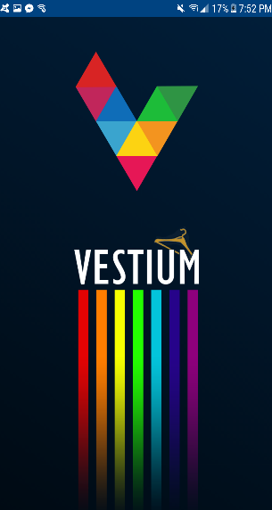

**‘Sign In’ Page:**

On opening the app, the user is presented with a sign in page. On tapping the sign in button on the bottom of the page, the user is asked the choice of google account they want to sign in from. Upon selecting the account, the home screen of the application shows. If internet is not available, the sign in page simply shows a message that internet is not available if the user is not signed in yet. But, if the user had signed in previously, regardless of internet availability, the app opens the home page for the user instead of the login page.

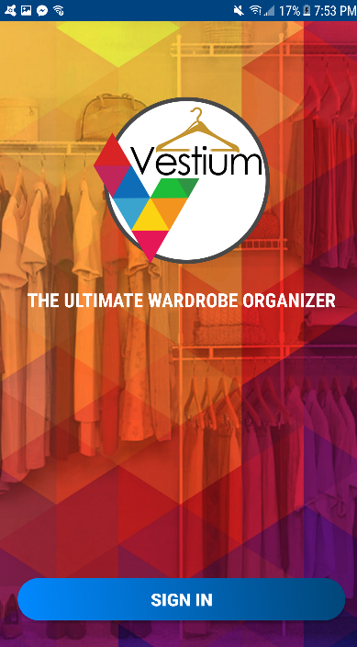

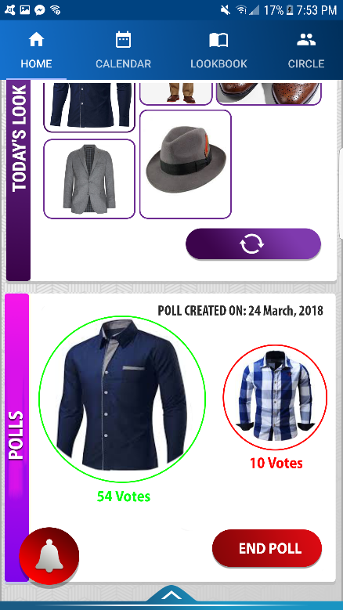**The Home Screen:**

Top Tabs Bar Options: The tabs bar at the top of the page displays four options. The user can either swipe left or right to access each activity or even tap on one of the four icons.

* Home: This takes the user to the home page.
* Calendar: Takes the user to the calendar page where they are able to add an outfit look to a specific date.
* Look-Book: Takes the user to the page where all the user’s outfit looks are displayed in a block design layout.
* Circle: Takes the user to the friend circles page, where the user is able to interact with friends.

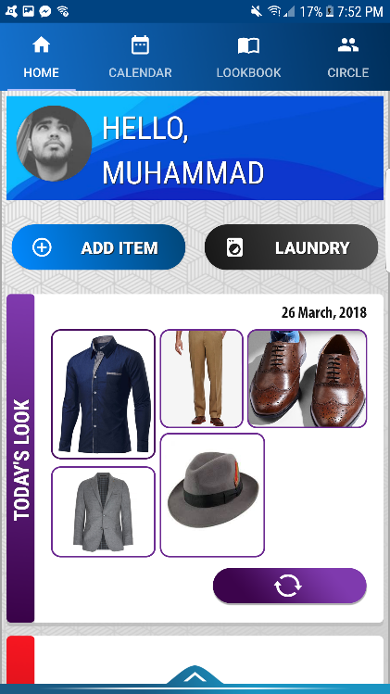

‘Add Item’ button: Displayed right after the top page tabs bar, this button allows the user to add items to their wardrobe. When the user taps on it, a pop up menu is displayed showing two options: ‘Camera’ and ‘Gallery’. Tapping the camera option opens the camera app. The user takes a picture of the relevant clothing item and is asked for confirmation. Upon confirming positive, the picture is displayed to the user. On the bottom of the displayed picture, there are two text fields. One of them is for the compulsory name of the clothing item, where the user can enter the name, and the second one is for any additional description they want to associate with that specific item. There are also three drop down menus, with a red star after 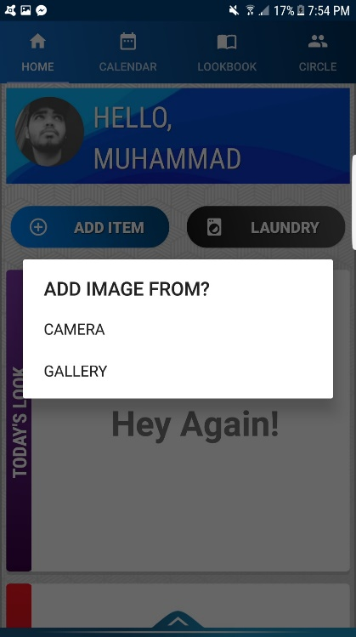each which means that the user cannot proceed with adding that clothing item without choosing one of the options. They are present below the text fields. The first one is for the category, which shows the possible categories of the clothing item: ‘Shirt’, ‘Pants’, ‘Shoes’, ‘Jacket’, ‘Sweater’, ‘Watch’, ‘Belt’ etc. The second one shows the possible styles of the clothing item and the third one is for the possible colors, upon selecting the latter one the user is presented with a dropdown menu showing some predefined basic colors. After the user fills in the text fields and selects the desired option from the drop down menus, they can tap the button which says “ADD” and are taken back to the home page and a message appears on the bottom of the screen saying “Item added to wardrobe”, the clothing item is, thus, saved in their wardrobe. If the user taps the gallery option, they are simply taken to their phone’s gallery and the user can select the image they want to add.

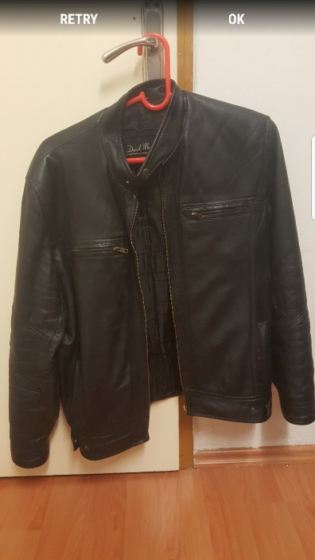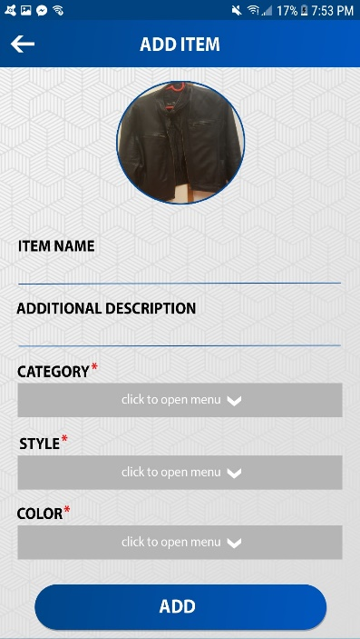

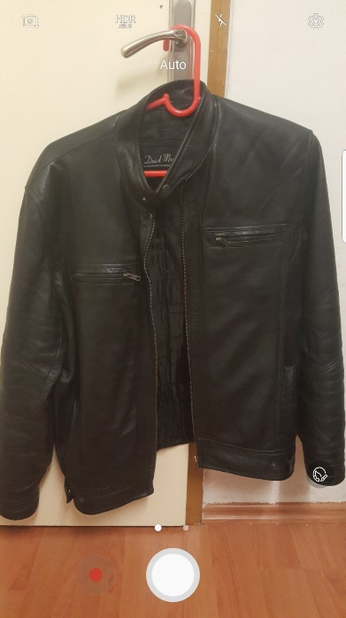

Laundry button: Present at the right of the ‘Add item’ button, tapping this button takes the user to the laundry activity where they can manage the clothing items that were added to the laundry. This button is also present in the menu bar (discussed later), but this one being on the home screen acts as a quick access button.

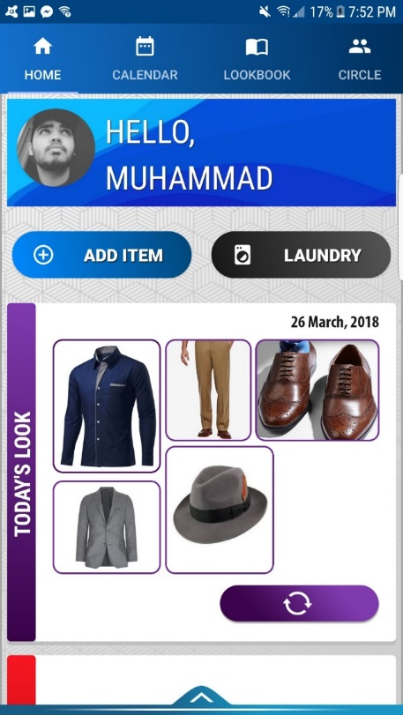

‘Today’s Look’ pane: The suggested look for the current day is displayed below the ‘Laundry’ and ‘Add Item’ buttons. It shows all the items of clothing in the outfit look in a block design layout. If the user is not satisfied with the suggestion, they can tap the ‘reload’ button at the bottom right side of the pane, which causes the program to suggest a different outfit for the day. The top right corner of the pane shows the current date.

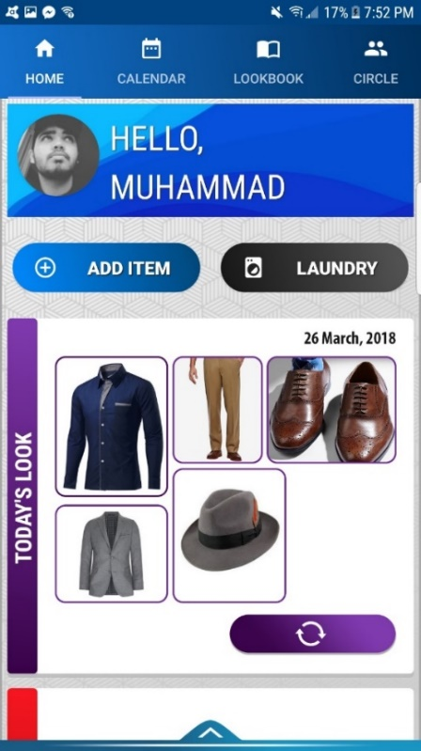

‘Notifications’ floating button: This button is present in the bottom left of the screen as a bell icon. Tapping it will take the user to the notifications activity where notifications about friend polls, latest deals, or any news about laundry or donations will be displayed. The user is able to tap any of the notifications and are taken to the relevant page. For example, if the notification is about one the user’s friends creating a new poll, tapping it would take the user to the page where that poll will be displayed. Similarly, tapping the one which says “6 items have been away for laundry for 15…” will take the user to the laundry activity.

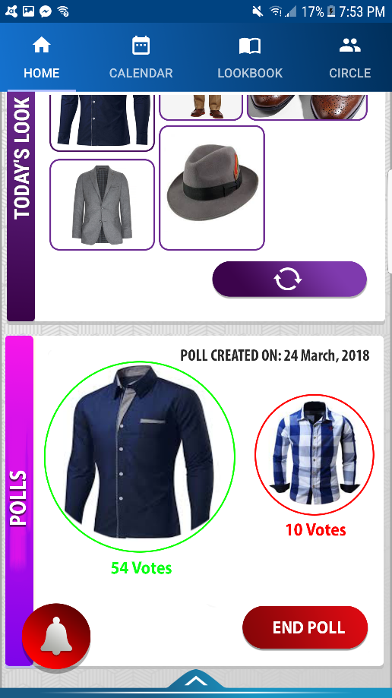

‘Polls’ pane: Present right below the ‘Todays Look’ pane, is the current ‘Polls’ pane. It shows the on-going poll that has been created by the user for their friends to vote on which clothing item should they wear for the day. The choices are displayed in separate circles. The one with higher votes is bordered in a bigger, green circle and the one with the lesser votes is inside a smaller, red circle. Below each circle, the number of votes each clothing item has gotten is showed. On the bottom right side of the panel is a button that says ‘End Poll’ which can be used by the user to delete the on-going poll. On the top right side of the panel, the date on which the poll was created is displayed.

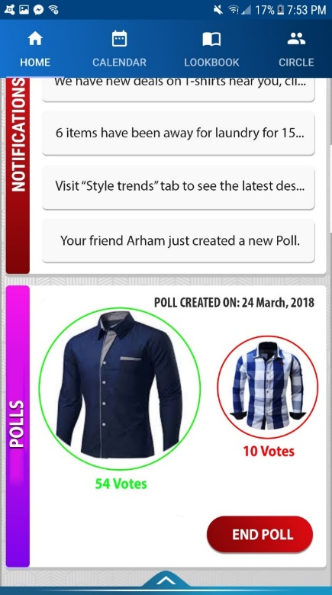

The menu bar: There is an arrow, facing upwards, present at the very bottom of the home screen. Tapping that arrow or swiping up brings forth the menu options panel. The panel slides from the bottom of the screen and is displayed to the user. The menu options panel consists of the following button options:

* Wardrobe: Takes the user to their wardrobe.
* Shopping: Takes the user to the shopping activity.
* Style Trends: Takes the user to the page where the latest style trends are displayed.
* Laundry: This is the same button as the one discussed before, which takes the user to page displaying the user’s laundry.
* Settings: Takes the user to the settings page.
* Wishlist: Takes the user to the wishlist activity.
* Sync Data: Synchronizes the user’s wardrobe with the online database.
* Log Out: Logs the user out of the application.
* Donations: Takes the user to the donations page

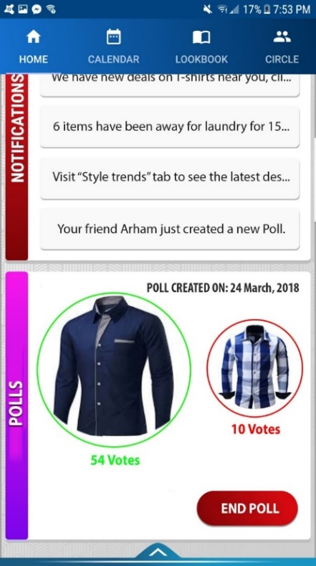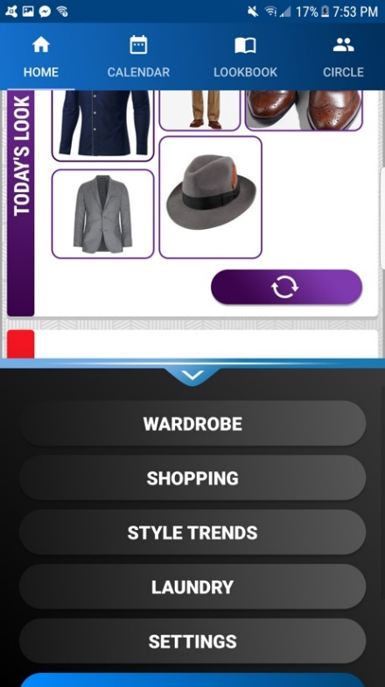

**LookBook:**

When the user swipes to the Lookbook tab or presses the "LOOKBOOK" button, the LookBook screen will appear and the user will be able to create new looks and display the looks, which the user has created before.

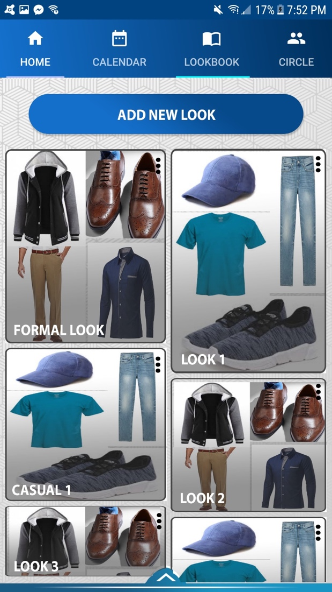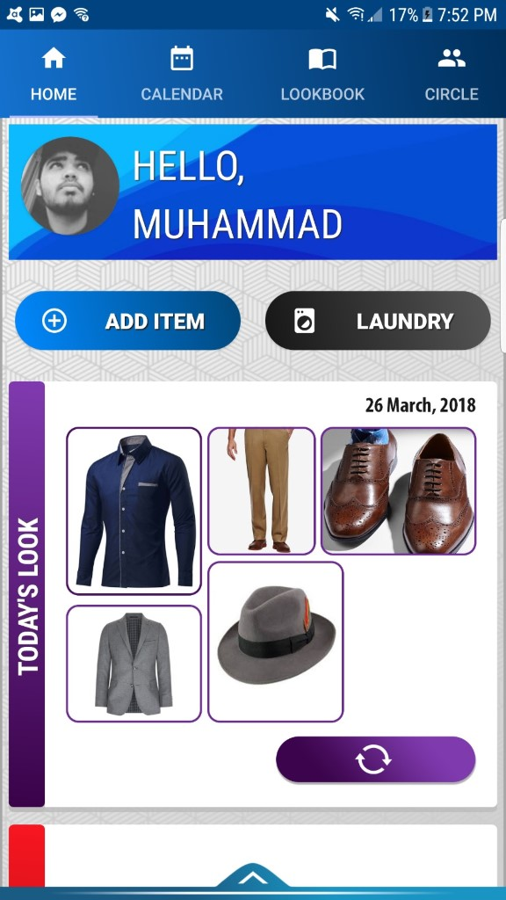

In the LookBook page, users can create new combinations from their wardrobe and will be called a "look". If the user press "ADD NEW LOOK" button, which is at the top of the page, the user is prompted to either select items for a look, or design the look in the” LOOK DESIGNER”. If select item is clicked, the "SELECT ITEMS" page is opened. In the select item page, all items are displayed in their categories and users can select just one item from each category which they want. If item is clicked two times, that item will be added to the look. In the “Look designer”, users are displayed carousels of different categories and the users can match how different items look together and save the present look. After adding items to the look, user can entitle it, but if the look is not entitled, it is entitled as default such as "LOOK1". After creating the new looks, the lookbook page display them in a neat way and the user can see them and scroll the page.

When the user presses the 3 dots button which is on the all Looks' top right corner, the application displays an option pane. In the option pane, user can select one of the options which are "EDIT LOOK" and "REMOVE LOOK". If the user selects "EDIT LOOK", application opens the user’s wardrobe and the look can be edited by adding and removing the items from user's wardrobe like creating a new look. If the user selects the "REMOVE LOOK", that look is removed from the LookBook page. Or user can click the backspace and close the option pane without selecting either of the options.

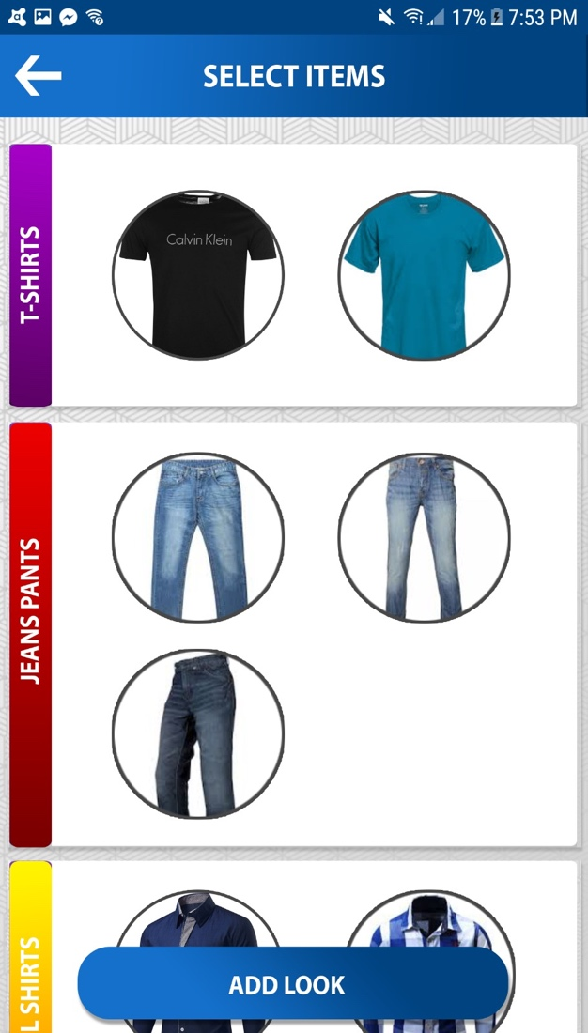

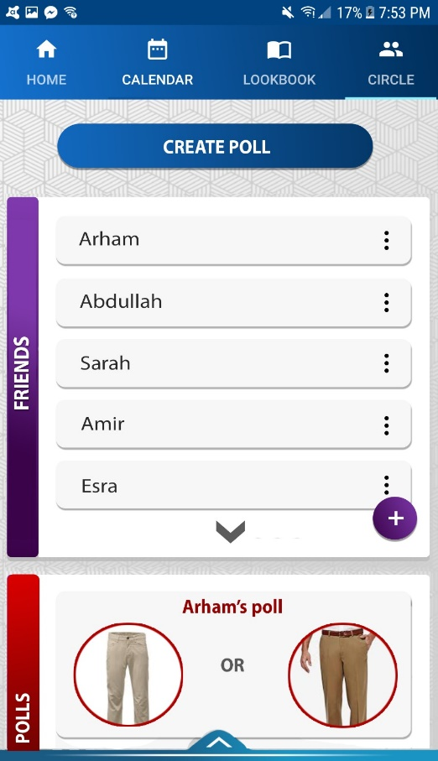**Circles:**

Vestium’s circle panel will have an option, which will allow the user to create polls and ask friends their opinion about a choice of two clothes. Upon pressing this button, users will be prompted with a new page, which will show list of clothes in their LookBook. The users can select two outfit combinations and add them to the poll. On the other hand, friends from their own circle tab can check the online polls that are live and pick one of the clothing combinations for their friend. These live polls are listed one after the other in the circle tab below friends list. In the same tab under create poll button there will be list of user’s friends, and a three-dot button providing variety of option to users. These options will include checking friend’s profile, checking the live polls for the selected friend and also checking friend’s wardrobe, with the option of adding any of the looks to users’ wishlist.

On the friend’s wardrobe page, there is a button with an exclamation, which allows the user to report another user after adding the reason for it. Upon receiving the report, the Vestium management analyses the report and blocks the user permanently from the platform.

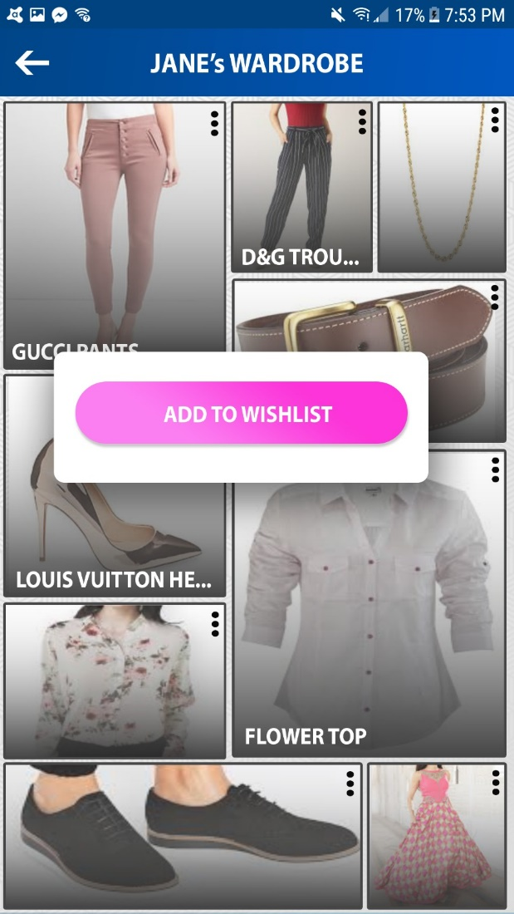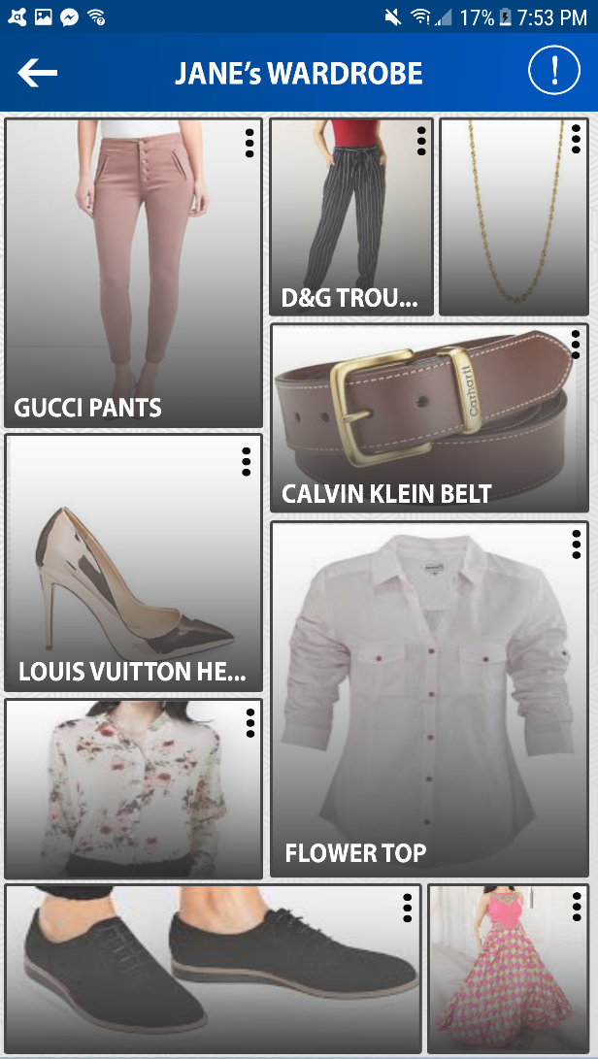

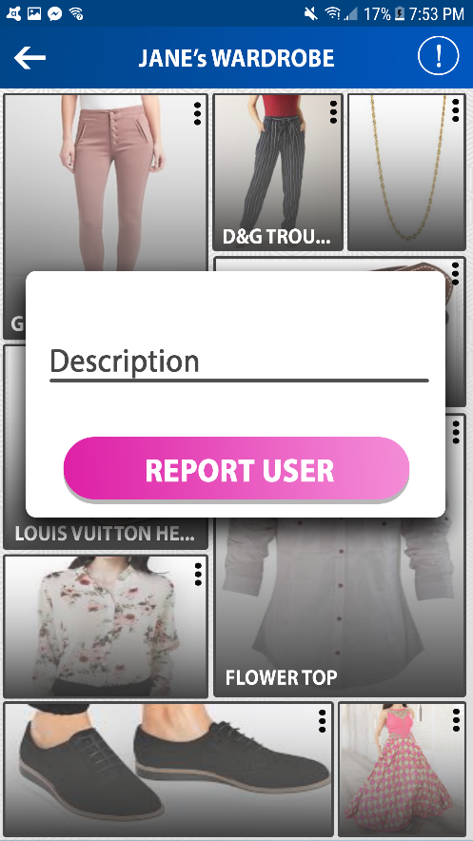

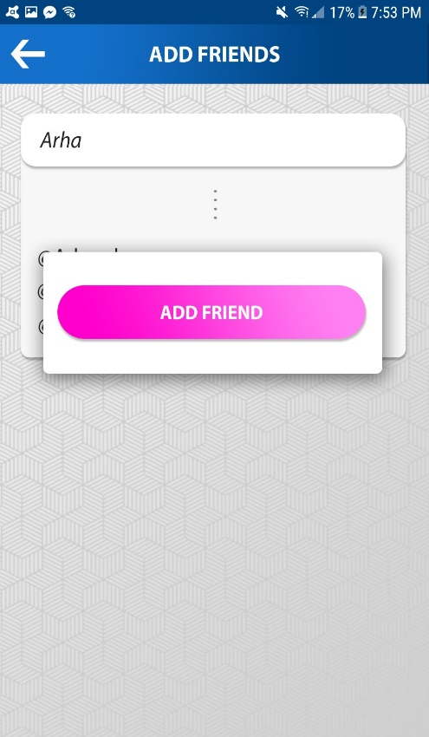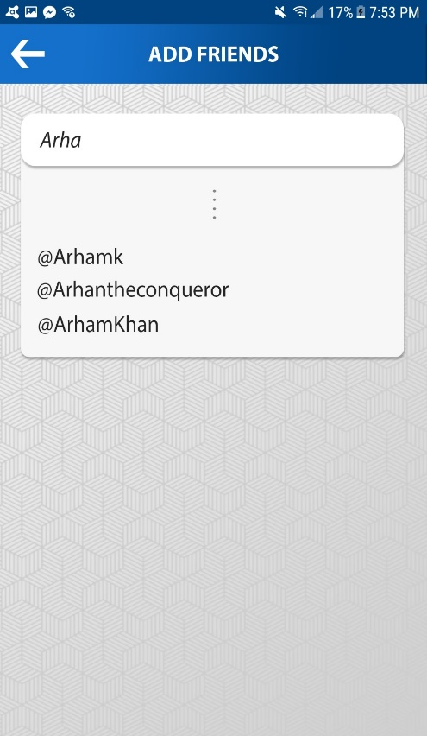Additionally, in the friends list, users can select plus sign option which will prompt users with a page where they can add new friends by looking up for their usernames in the search bar. Doing so will look for the list of users in our database and if a user(s) is found with a similar name, they can be added to the friends list by pressing on them and choosing ADD FRIEND option. When the add friend option is selected, the other user receives a notification asking if they want to confirm the friend request. If so, the user becomes friend with the other user and the users appear in each others friend list.

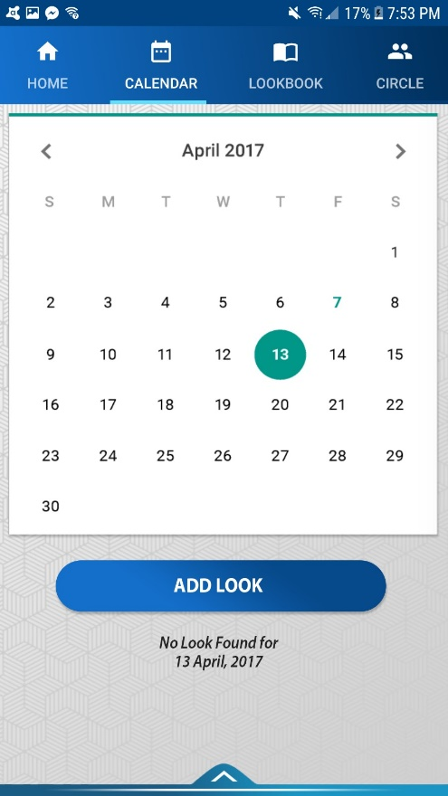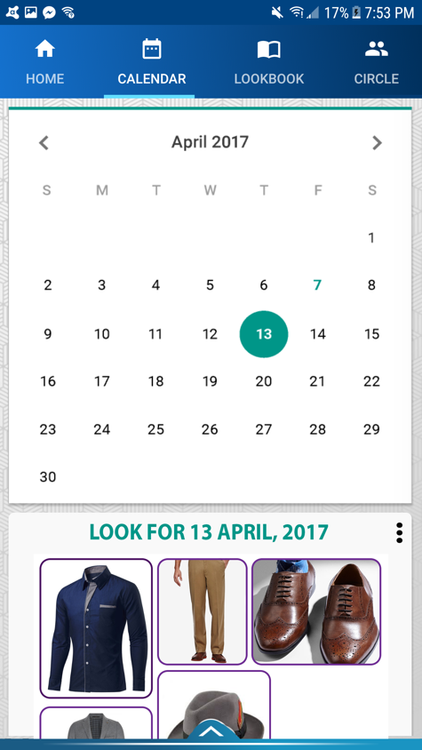**Calendar:**

The Calendar tab provides the ability to specify looks for each day and occasion, using the smooth and convenient google calendar. Features for calendar app include adding specific clothes, occasion name, and other information for specific days. If users click on a day, below the calendar there will be an option to add multiple looks and an occasion for each look. This will present the user with a pop that asks them if they want to add the look from the Lookbook or an item from the wardrobe. However, in case there already is a look for the day, then the “ADD LOOK” changes to “ADD ANOTHER LOOK” and is visible below the currently available looks. Upon clicking this, users are able to add virtually countless looks for a single day for different occasions. Additionally, clicking on the triple dot menu on a look, user is presented to either remove or edit a look.

**Wishlist:**

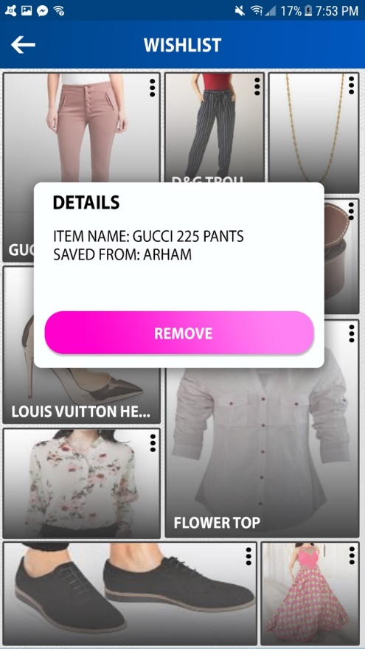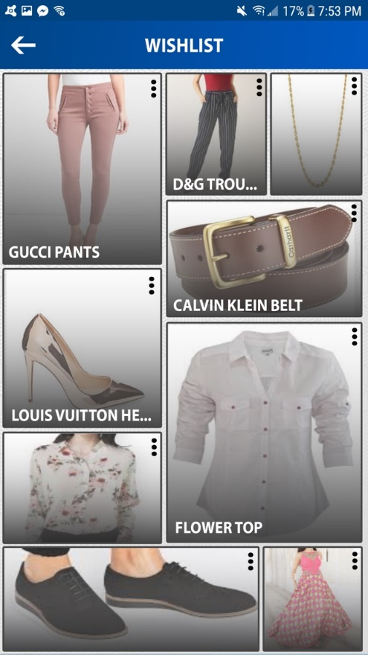In the Wishlist screen, the user is presented with all items that they have saved before. The items are displayed in a panel-like manner in a scrollable screen. To see the rest of the saved items, the user can scroll vertically. Tapping on the picture opens the item’s screen which displays the item’s picture alongside its description. However, tapping the three black dots on the items panel presents the user with a pop up. The popup, named “DETAILS”, displays the item’s name and from who this item was saved. Moreover, tapping the button “REMOVE” allows the user to remove this item from their Wishlist. If the user wishes to go back, the user can tap outside the popup in order to dismiss it.

**Donations:**

This page allows the user to see Vestium’s donation suggestions. The button at the top of the screen, “DONATE NEW ITEM”, allows the user to pick out one or more items to be donated. When tapped, the user is taken to “SELECT ITEMS” menu where the user can view all the available items for donation in his wardrobe. The user can scroll to view the rest of items. To select the desired outfits,

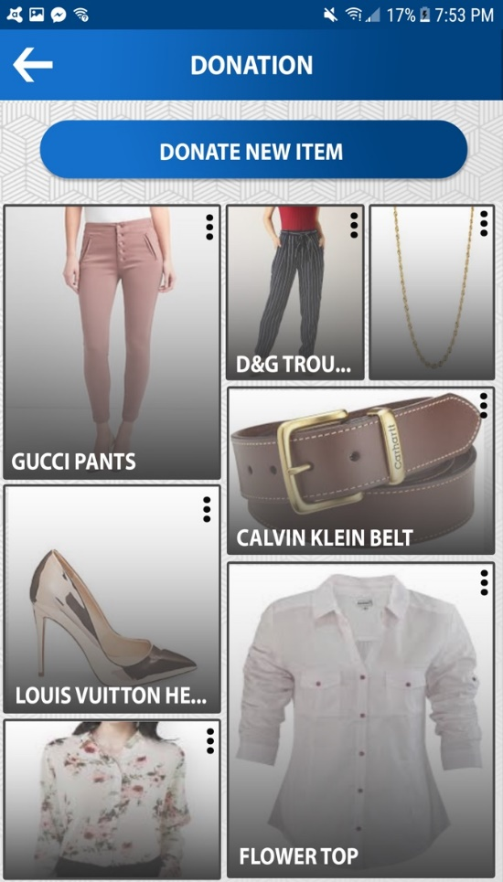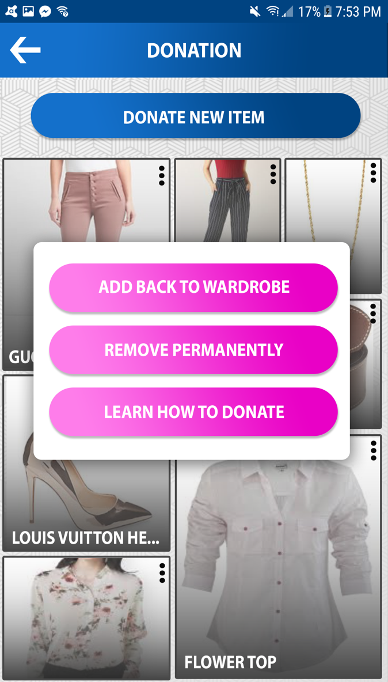

the user can tap on the item. To unselect, the user needs to tap on the already selected item. When the user is done selecting items, they can tap “DONE” at the top right part of the screen. Next to the “DONE” button, a count of the selected clothes will be displayed between parentheses. After the user taps done, they are taken back to the updated donations screen. The selected items are then displayed in a panel-like manner. Each panel represents an item that was selected to be donated. The picture shows the item. If the picture is tapped, the user will be taken to the items menu which shows a picture of the item and its description. If the 3 black dots are pressed, the user is presented with a small popup. The first option, “ADD BACK TO WARDROBE”, removes the item from the donations tab and adds it back to the user’s wardrobe. When the user has donated and item, they can select the second option, “REMOVE PERMANENTLY”, which removes the item completely and it will not appear in the wardrobe or the donations screen. The third option, “LEARN HOW TO DONATE”, takes the user to a screen that shows various charities’ contact pages.

**Wardrobe:**

The wardrobe activitydisplays all the items that the user has added in their wardrobe. There is a three-dot button on the top right corner of each item**.** When the user taps that button, the date on which the specific item was added is displayed.

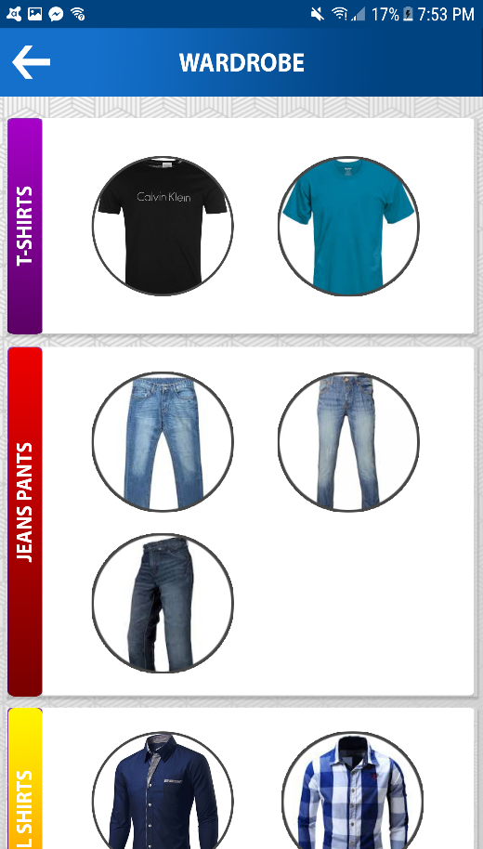

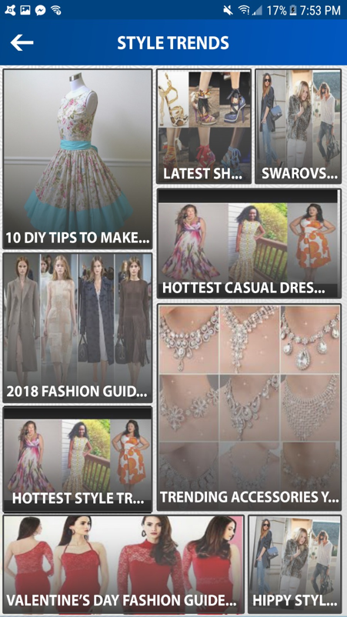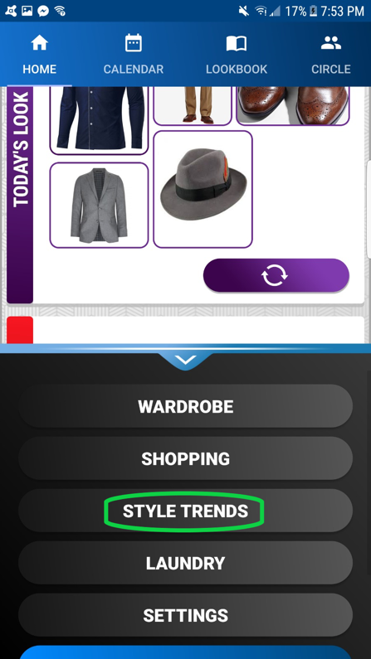**Style Trends:**

The user can access to style trends page inside the menu like shopping page. The user can see the style trends page with pressing the style trends button inside the menu. At the top of the style trends page, there is a text which demonstrate that the user is in the style trends page. At the upper left corner of the page, there is an arrow button which the user can reach to the previous page with click on it. Inside of the page, the program shows images of latest trends to the user. The application gets the information from fashion sites e.g., elle.com, instyle.com. At the bottom of each image, it shows the title of the trend. If the user clicks the image, the program will open the web browser and show its web site.

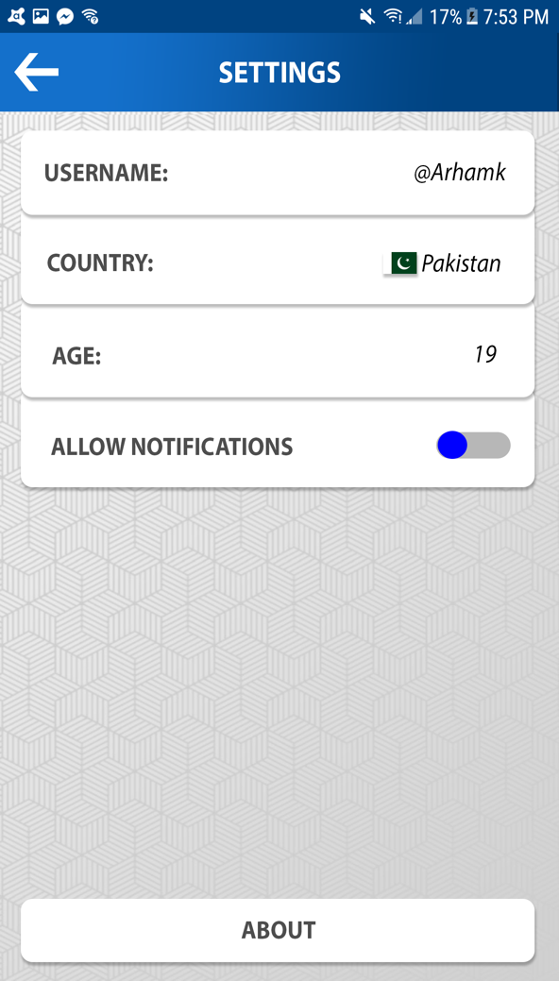**Settings:**

This page allows the user to change his preferences. The first option, titled “USERNAME”, presents the user with a popup, which allows the user to input their preferred username. After the user decides their wanted username, they can tap “SAVE” in order to update their username in Firebase. The second option, “COUNTRY”, allows the user to update the country in which the user resides in. By clicking on it, the user is presented with a popup that contains a scrollable list of options. The second option uses the user’s GPS information in order to find the country, while the rest of the list contains a list of the countries alongside their flags in alphabetical order. Once an option is tapped, the menu disappears and the preferences are saved and synced. The third option, “AGE”, allows the user to update their age setting in their profile. They are presented with a sub-menu that allows the users to change the numbers by scrolling multiple wheels. The fourth and last option, “ALLOW NOTIFICATIONS”, allows the user to update their notifications preference by tapping on the button. If turned on, Vestium’s notifications can use and access Android’s notification system to notify the user even if they are not using Vestium. However, if turned off, Vestium’s notifications are limited only to the application.

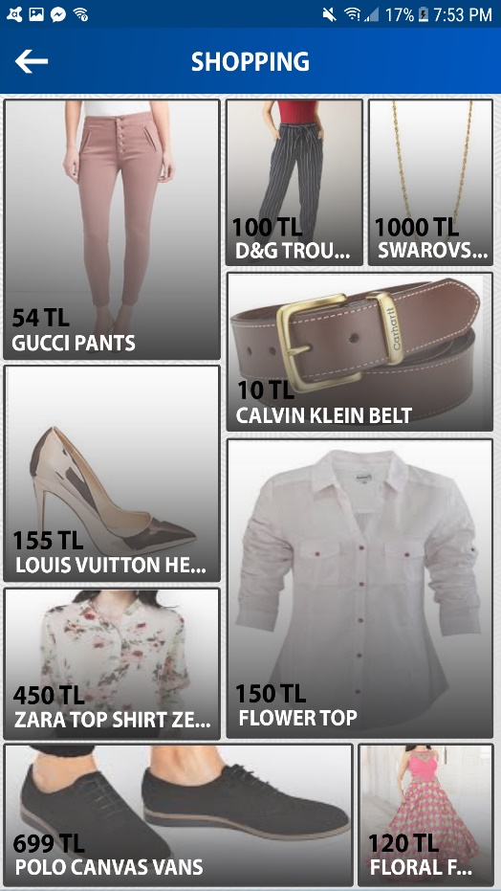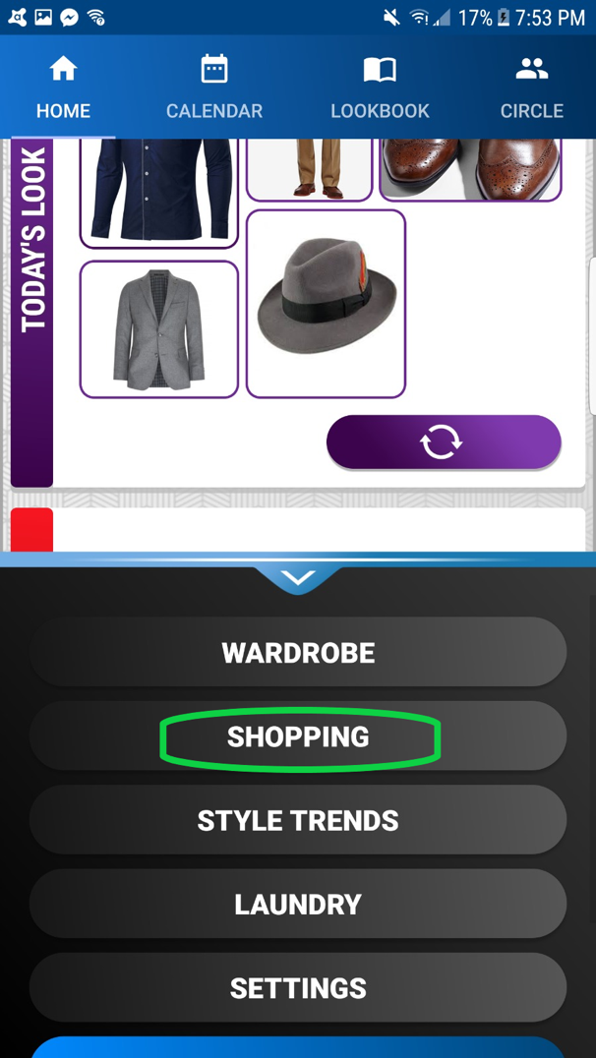

**Shopping:**

The user can access to shopping page inside the menu which the can reach with press the drop up button. With pressing the shopping button inside the menu, the user can see the shopping page.

Inside the shopping page, at the top of the page there is a text, which demonstrate that the user is in the shopping page. At the upper left corner, there is a arrow button which the user can reach to the previous page with click on it. Inside of the page, the program displays images of popular clothes to the user in order to user’s preference. The application gets the information from Google Shopping API. In each image, at the bottom of the image it shows the title and the price of the item. If the user presses the image, the program will open the web browser and show its web site.

**Laundry:**

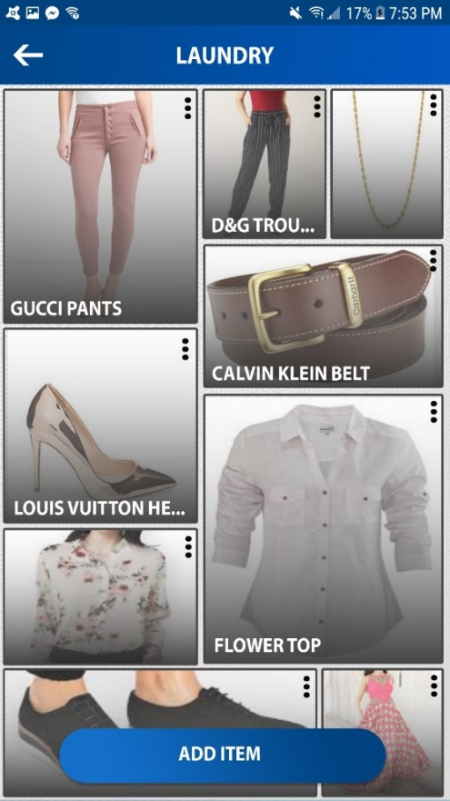Whenever you open the Vestium, after logging in to your account and in Home Screen, there are two ways which you can access the Laundry screen. One way is by pressing the button next to ‘ADD ITEM’ button. By pressing that, you would be redirected to the Laundry section of Vestium. Another way to open the Laundry section is by opening it from the drop-up menu located in the bottom of the Home Screen.

After being redirected to the Laundry section, a new window with all the clothes in the laundry would show up with a list of the clothes in laundry with each of them having a details menu option located in the top right corner of them to remove the item from the Laundry and also an ADD ITEM button to add more items to the laundry. The ADD ITEM button will redirect to the whole wardrobe (list of all clothes) window.

The new window will have the list of items in the wardrobe and the user can select which items to be added to the Laundry. When the details button of each item is tapped, there would be details about the selected item, name and date, and a button to remove the item from the Laundry.

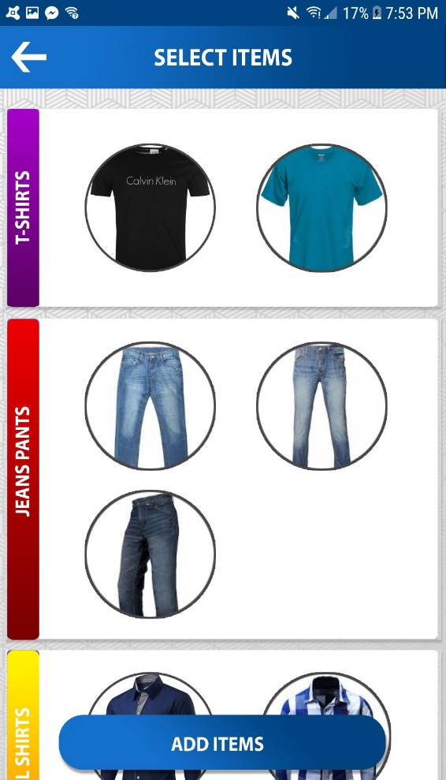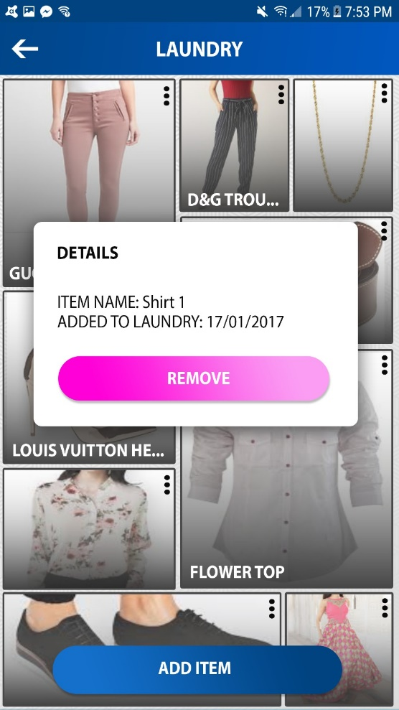

# Inspirations & Ideas

The User-interface design is inspired from Google Material Design Library [4] and Florent37’s design elements available on Github [3]. Additionally, the diverse color theme of the application comprising of rainbow colors represents a user’s wardrobe containing articles of all colors and types. Yet still, the application largely relies on shades of blue because according to color theory, blue signifies trust and usefulness [6], both of which Vestium aims to achieve.

The design of vestium is also inspired from various applications available in the market such as Facebook [1], SnapChat [2], Google Search etc. and strictly follows user-interface design standards set by the open-source UI design community available on Github [5]. Furthermore, Vestium’s design is made keeping the average user in mind, who has liminal knowledge of application usage, to improve its usability and increase user satisfaction.

The prime design rule during Vestium’s design has been simplicity because since the app aims to simplify user’s dress selection process, it should be user friendly and easy to use too. Hence, throughout the application, excessive use of elements, such as buttons, texts etc., has been avoided and the design has been kept clean and appealing. Furthermore, Vestium also features uniformity in different activities so that the user is not surprised with the usage on every activity.

# Conclusion

Vestium’s versatility in choosing and indexing clothes makes it an innovative platform to select daily clothes based on multiple factors, and sharing them with friends. This innovative idea, coupled up with the clean and appealing UI design, will make Vestium a smart choice to manage a user’s wardrobe and hence, will set it apart from other such applications available in the market.

# References

|  |  |
| --- | --- |
| [1] | “Facebook,” [Online]. Available: https://www.facebook.com. |
| [2] | “SnapChat,” [Online]. Available: https://www.snap.com. |
| [3] | “Florent37,” Github, [Online]. Available: https://github.com/florent37. |
| [4] | “Google Material Design,” Google, [Online]. Available: https://material.io. |
| [5] | “Google Material Component Guidelines,” Github, [Online]. Available: https://github.com/material-components/material-components-android. |
| [6] | C. Chapman, “Color Theory for designers,” [Online]. Available: https://www.smashingmagazine.com/2010/01/color-theory-for-designers-part-1-the-meaning-of-color/. |